Kubernetes Task 4
.
1. Deploy an application using a Deployment with 3 replicas and a rolling update strategy..
2. Configure a Deployment with a Recreate strategy and observe the downtime..
3. Update an existing Deployment and perform a rollback to the previous version..
4. Modify a Deployment to add resource requests and limits for CPU and memory..
5. Create a Deployment with MaxSurge and MaxUnavailable configurations..
6. Set up a Deployment with a custom revision history limit..
7. Pause a Deployment during an update, and then resume it..
8. Create a pod using resource requests for memory and CPU, and observe how the scheduler assigns it to a node..

Task 1 — Deployment with 3 Replicas + Rolling Update
Goal
We need to create:
Deployment
|
├── nginx Pod 1
├── nginx Pod 2
└── nginx Pod 3
And configure:
replicas: 3
strategy: RollingUpdate
With RollingUpdate, when we update the application version, Kubernetes gradually replaces the old Pods instead of stopping everything at once.
Step 1 — Create Deployment YAML
Run:
nano deployment-rolling.yml
Paste the complete file:
apiVersion: apps/v1
kind: Deployment
metadata:
name: nginx-deployment
spec:
replicas: 3
strategy:
type: RollingUpdate
selector:
matchLabels:
app: nginx-deployment
template:
metadata:
labels:
app: nginx-deployment
spec:
containers:
- name: nginx
image: nginx:1.27
ports:
- containerPort: 80
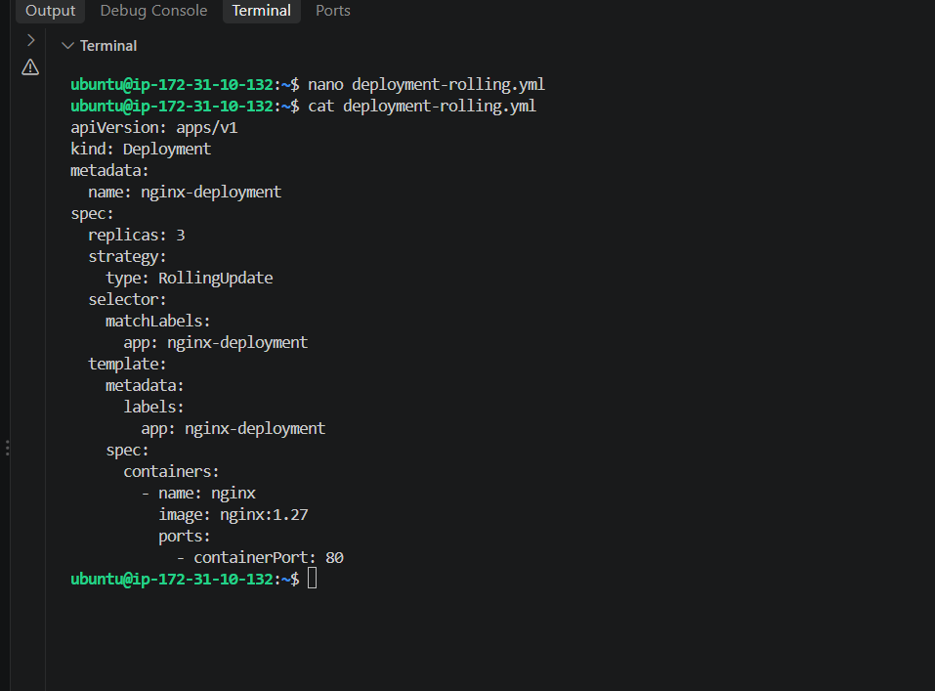
Step 2 — Create Deployment
kubectl apply -f deployment-rolling.yml
Expected:
deployment.apps/nginx-deployment created
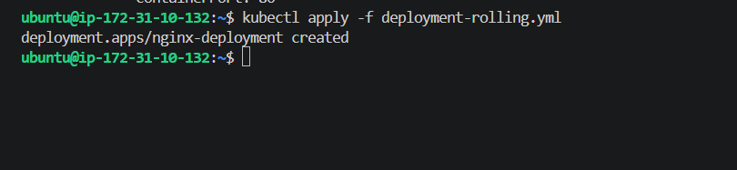
Step 3 — Check Deployment
kubectl get deployment
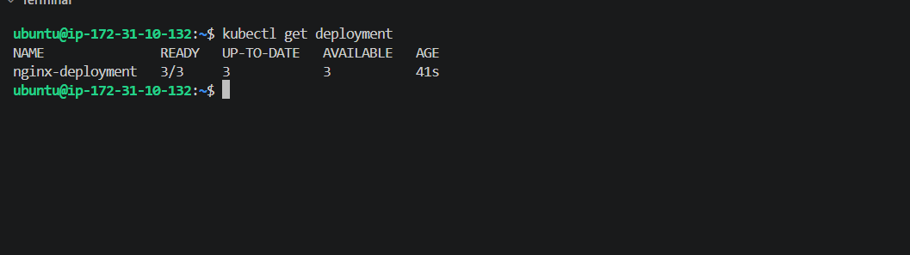
Step 4 — Check ReplicaSet
A Deployment automatically creates a ReplicaSet.
Run:
kubectl get rs
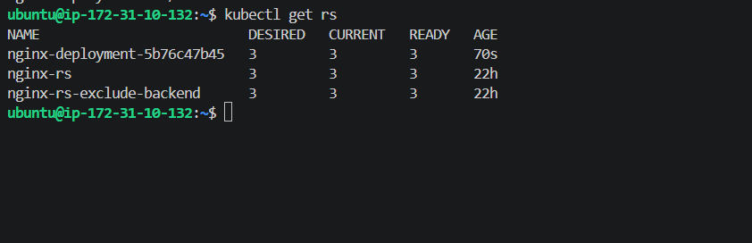
Step 5 — Check Pods
kubectl get pods -l app=nginx-deployment -o wide
Step 6 — Verify RollingUpdate strategy
Run:
kubectl get deployment nginx-deployment -o yaml | grep -A5 strategy
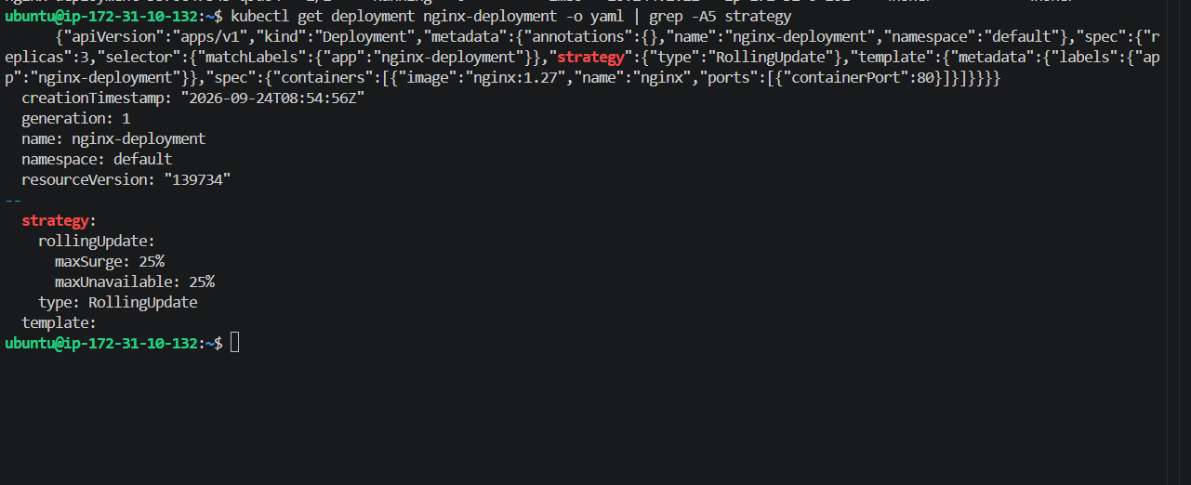
Task 2 — Deployment with Recreate Strategy
Now we need to create a Deployment using:
strategy:
type: Recreate
What is Recreate?
With RollingUpdate:
Old Pods
↓
New Pods gradually created
↓
Old Pods gradually removed
With Recreate:
Old Pods
↓
ALL old Pods deleted
↓
DOWNTIME
↓
New Pods created
So this task is specifically to observe the downtime.
Step 1 — Create Recreate Deployment
Run:
nano deployment-recreate.yml
Paste the complete file:
apiVersion: apps/v1
kind: Deployment
metadata:
name: nginx-recreate
spec:
replicas: 3
strategy:
type: Recreate
selector:
matchLabels:
app: nginx-recreate
template:
metadata:
labels:
app: nginx-recreate
spec:
containers:
- name: nginx
image: nginx:1.27
ports:
- containerPort: 80
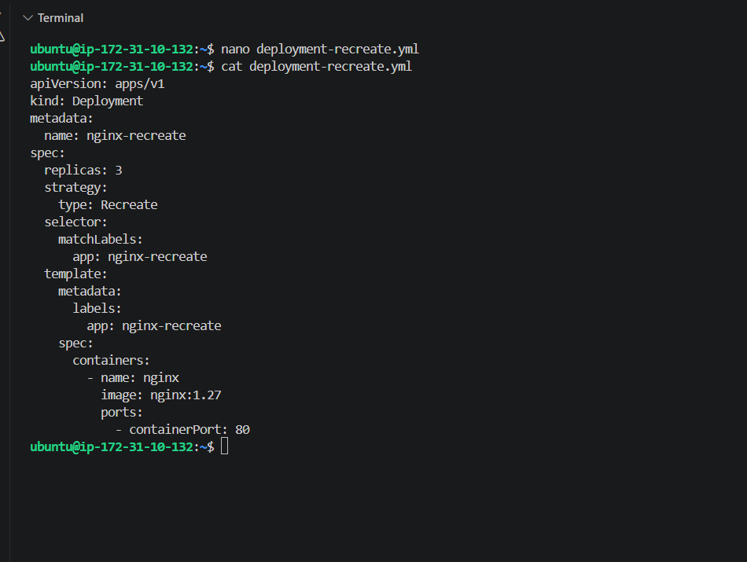
Step 2 — Apply
kubectl apply -f deployment-recreate.yml
Check:
kubectl get deployment nginx-recreate
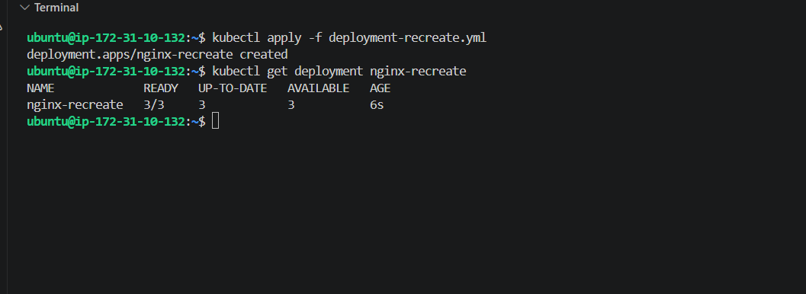
Step 3 — Verify strategy
kubectl get deployment nginx-recreate -o yaml | grep -A5 strategy
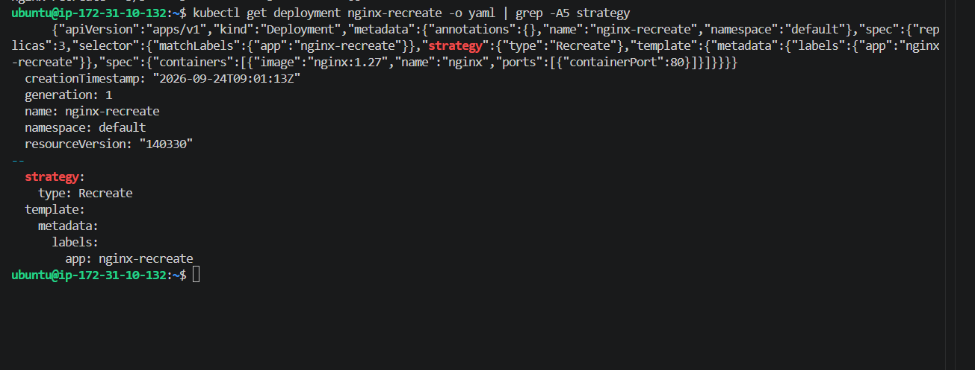
Step 4 — Create a Service
To observe downtime properly, expose the Deployment through a ClusterIP Service.
Create:
nano nginx-recreate-service.yml
apiVersion: v1
kind: Service
metadata:
name: nginx-recreate-service
spec:
type: ClusterIP
selector:
app: nginx-recreate
ports:
- protocol: TCP
port: 80
targetPort: 80
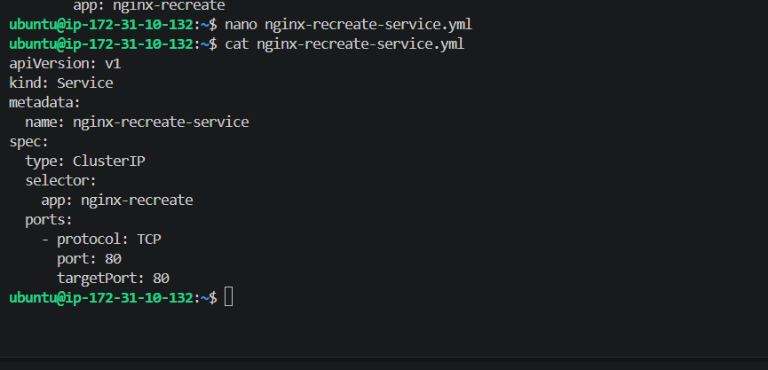
Save and apply:
kubectl apply -f nginx-recreate-service.yml
Check:
kubectl get svc nginx-recreate-service
And:
kubectl get endpoints nginx-recreate-service
You should see the 3 Pod IPs.
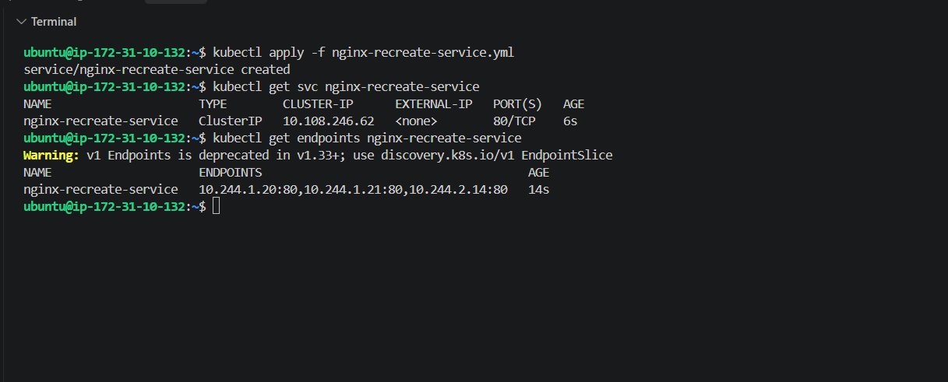
Step 5 — Observe Recreate behavior
First check:
kubectl get pods -l app=nginx-recreate
You should have 3 Pods.
Now change the image from:
nginx:1.27
to:
nginx:1.28
The easiest way:
kubectl set image deployment/nginx-recreate nginx=nginx:1.28
Immediately watch:
kubectl get pods -l app=nginx-recreate -w
You should observe the old Pods being terminated before the new Pods become Ready.
You can also watch the endpoints in another terminal:
kubectl get endpoints nginx-recreate-service -w
The important observation is:
Old Pods
↓
Terminated
↓
0 available Pods
↓
New nginx:1.28 Pods created
↓
New Pods Ready
That temporary period with no available Pods is the downtime caused by the Recreate strategy.
Don't worry if the downtime is very short
Nginx starts quickly, so the gap may only last a few seconds. The important thing is the behavior:
Recreate = terminate old version first → create new version afterward.
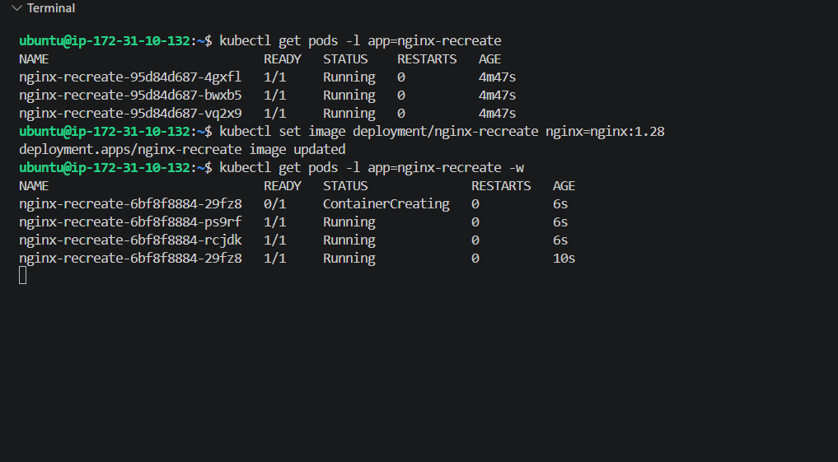 Task 2 is confirmed.
We– started with 3 Pods:
nginx-recreate-95d84d687-4gxfl Running
nginx-recreate-95d84d687-bwxb5 Running
nginx-recreate-95d84d687-vq2x9 Running
Then you changed:
kubectl set image deployment/nginx-recreate nginx=nginx:1.28
Because the Deployment uses:
strategy:
type: Recreate
Kubernetes created a new ReplicaSet:
nginx-recreate-6bf8f8884ṣ
and the new Pods came up as:
0/1 ContainerCreating
1/1 Running
1/1 Running
The important observation is that the old nginx-recreate-95d84d687-* Pods disappeared before the new Pods became available. That is the Recreate strategy behavior.
Task 2 result
Old version 1.27
↓
Old Pods terminated
↓
Temporary 0 available Pods
↓
New version 1.28 Pods created
↓
3 new Pods Running

Task 3 — Update Deployment and Rollback
Now we'll learn one of the most important Deployment features:
Update → New ReplicaSet → Something wrong → Rollback
Step 1 — Create Deployment
nano deployment-rollback.yml
Paste:
apiVersion: apps/v1
kind: Deployment
metadata:
name: nginx-rollback
spec:
replicas: 3
revisionHistoryLimit: 10
strategy:
type: RollingUpdate
selector:
matchLabels:
app: nginx-rollback
template:
metadata:
labels:
app: nginx-rollback
spec:
containers:
- name: nginx
image: nginx:1.27
ports:
- containerPort: 80
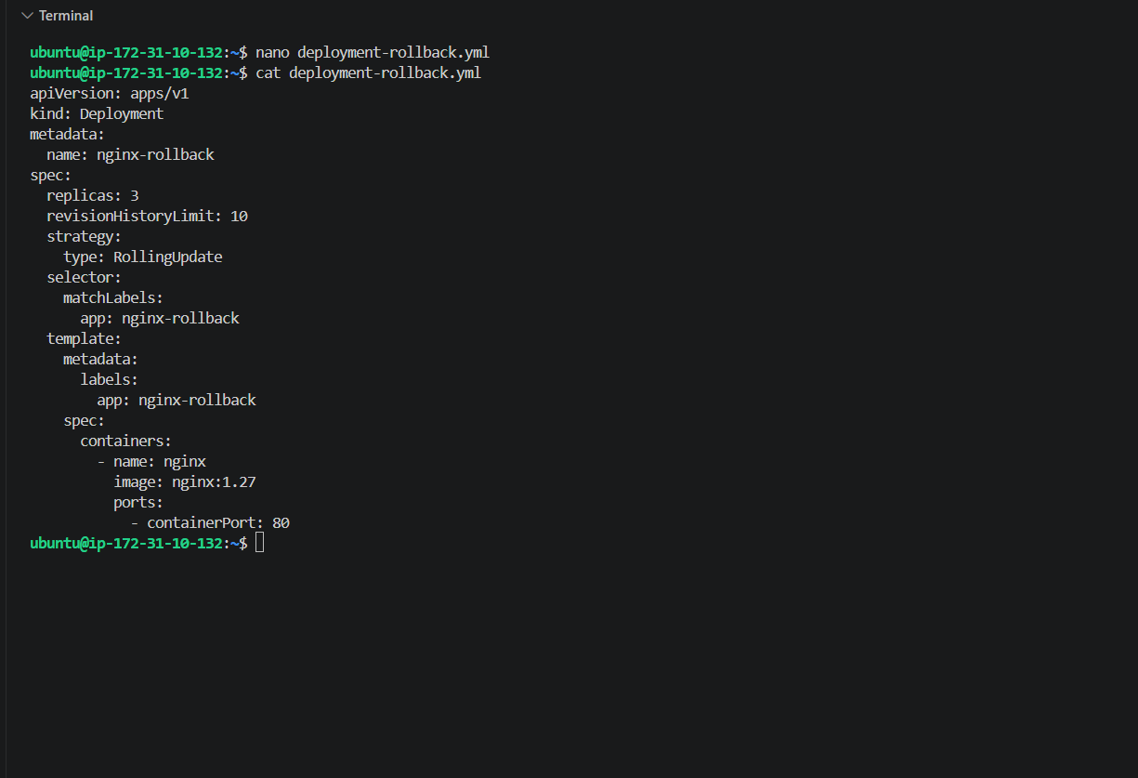
Apply:
kubectl apply -f deployment-rollback.yml
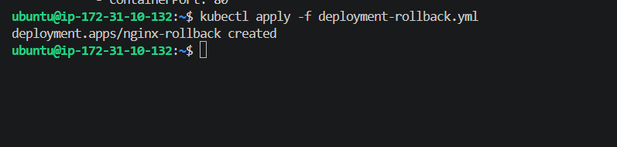
Step 2 — Verify version 1.27
kubectl get deployment nginx-rollback
Then:
kubectl get pods -l app=nginx-rollback
And verify the image:
kubectl get deployment nginx-rollback -o jsonpath='{.spec.template.spec.containers[0].image}'
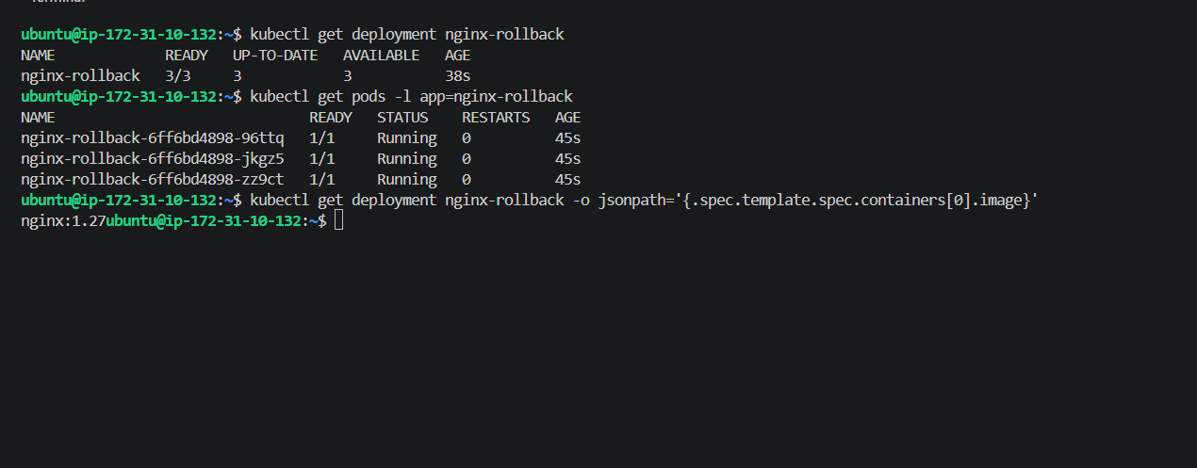
Step 3 — Update to 1.28
Run:
kubectl set image deployment/nginx-rollback nginx=nginx:1.28
Then:
kubectl rollout status deployment/nginx-rollback
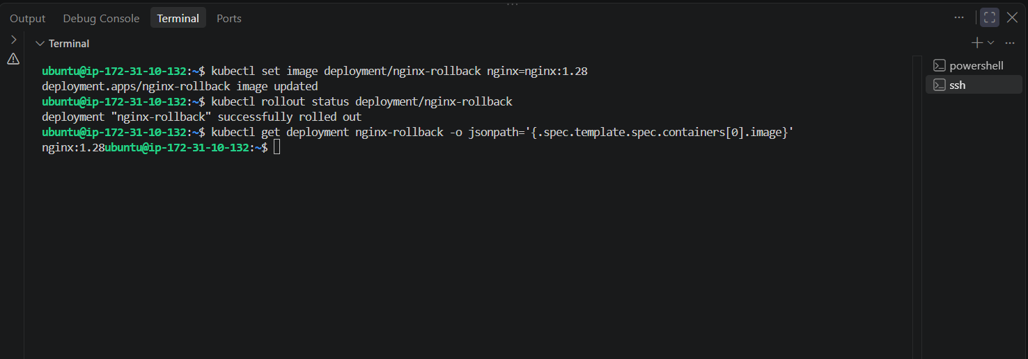
Step 4 — Check rollout history
kubectl rollout history deployment/nginx-rollback
You should see revisions similar to:
REVISION
1
2
Meaning:
Revision 1 → nginx:1.27
Revision 2 → nginx:1.28
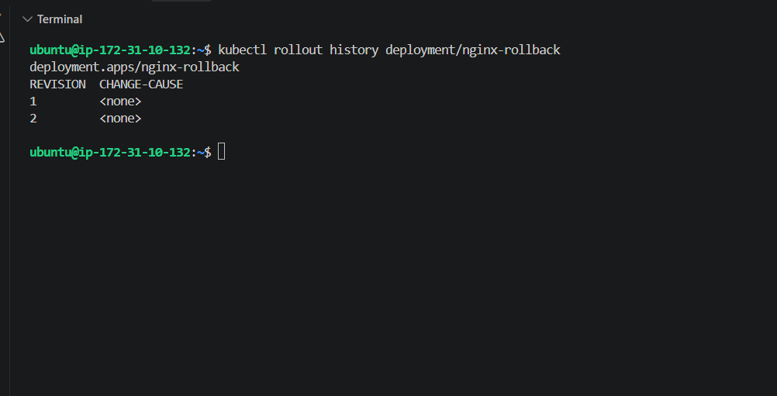
Step 5 — Rollback
Now we'll return to the previous version:
kubectl rollout undo deployment/nginx-rollback
Check:
kubectl rollout status deployment/nginx-rollback
Then verify:
kubectl get deployment nginx-rollback -o jsonpath='{.spec.template.spec.containers[0].image}'
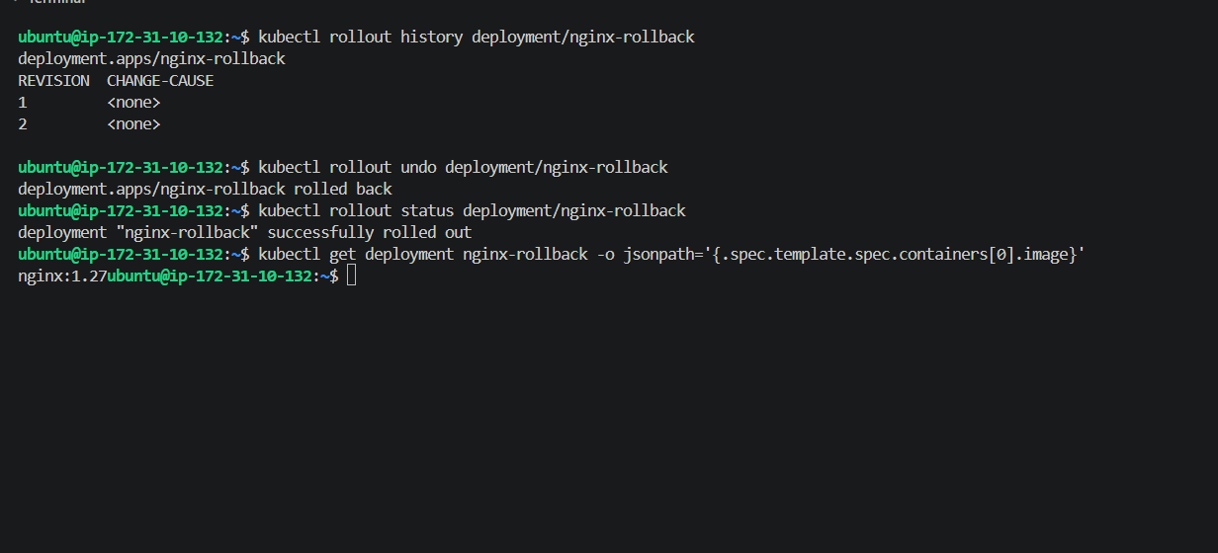
The complete flow
Revision 1
nginx:1.27
↓
Update
↓
Revision 2
nginx:1.28
↓
rollout undo
↓
Previous configuration
nginx:1.27
Task 4 — Resource Requests and Limits
Goal
We need to configure:
CPU request = 100m
CPU limit = 200m
Memory request = 128Mi
Memory limit = 256Mi
The final Deployment will look like:
Deployment
|
└── ReplicaSet
|
3 Pods
|
nginx
├── CPU Request: 100m
├── CPU Limit: 200m
├── Memory Request: 128Mi
└── Memory Limit: 256Mi
Step 1 — Replace deployment-rollback.yml
Run:
nano deployment-rollback.yml
Replace the entire file with:
apiVersion: apps/v1
kind: Deployment
metadata:
name: nginx-rollback
spec:
replicas: 3
revisionHistoryLimit: 10
strategy:
type: RollingUpdate
selector:
matchLabels:
app: nginx-rollback
template:
metadata:
labels:
app: nginx-rollback
spec:
containers:
- name: nginx
image: nginx:1.27
ports:
- containerPort: 80
resources:
requests:
cpu: "100m"
memory: "128Mi"
limits:
cpu: "200m"
memory: "256Mi"
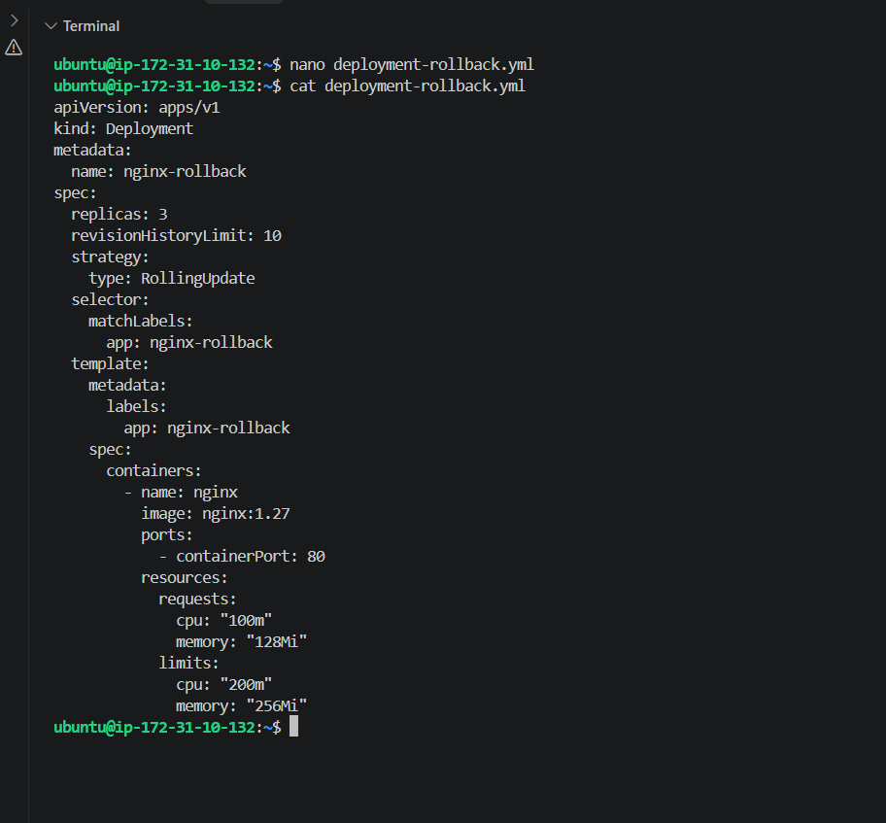
Step 2 — Apply the change
kubectl apply -f deployment-rollback.yml
Check:
kubectl rollout status deployment/nginx-rollback
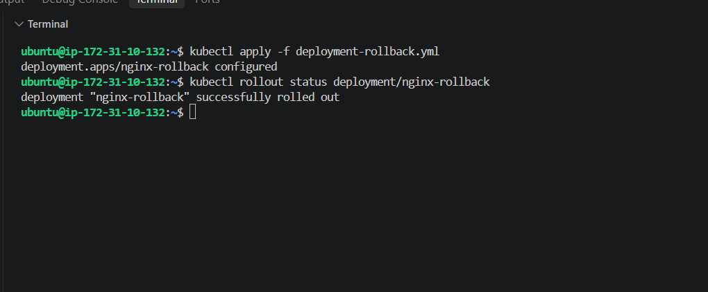
Step 3 — Verify the resource configuration
Run:
kubectl describe deployment nginx-rollback
Look for:
Requests:
cpu: 100m
memory: 128Mi
Limits:
cpu: 200m
memory: 256Mi
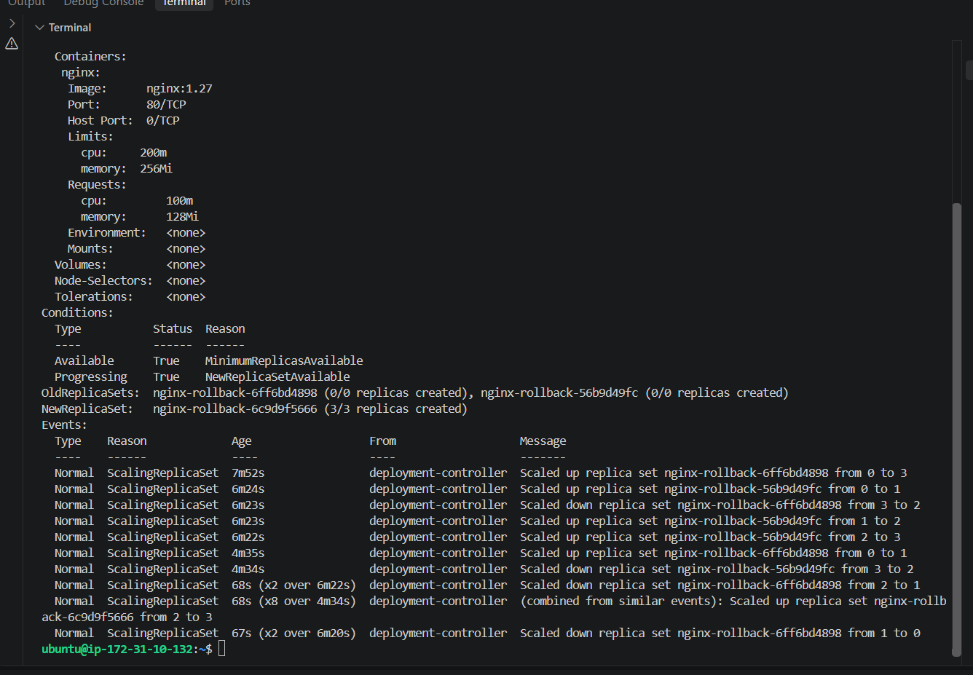
Step 4 — Verify directly from the Pod
First get a Pod name:
kubectl get pods -l app=nginx-rollback
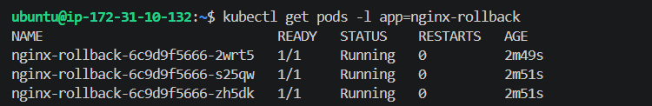
Task 5 — MaxSurge and MaxUnavailable
Now continue with the new Deployment nginx-surge.
1. Create the file
nano deployment-surge.yml
Paste the complete file:
apiVersion: apps/v1
kind: Deployment
metadata:
name: nginx-surge
spec:
replicas: 4
strategy:
type: RollingUpdate
rollingUpdate:
maxSurge: 1
maxUnavailable: 1
selector:
matchLabels:
app: nginx-surge
template:
metadata:
labels:
app: nginx-surge
spec:
containers:
- name: nginx
image: nginx:1.27
ports:
- containerPort: 80
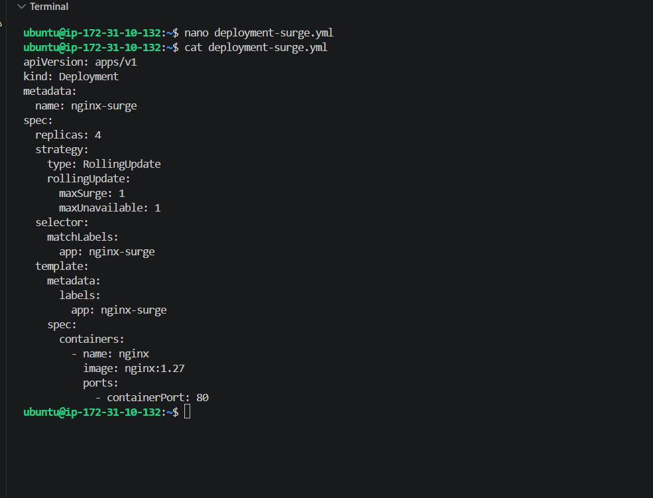
2. Apply
kubectl apply -f deployment-surge.yml
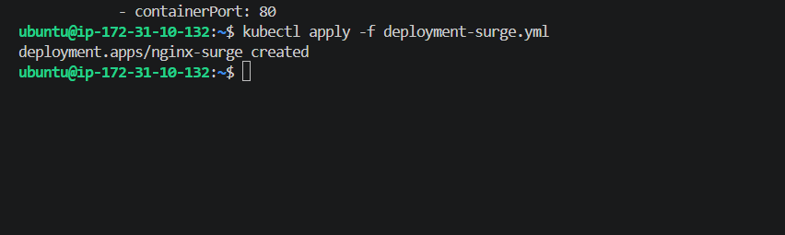
Then:
kubectl rollout status deployment/nginx-surge
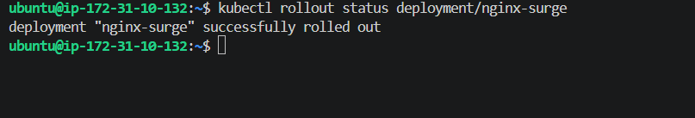
3. Verify the configuration
kubectl get deployment nginx-surge
And:
kubectl get deployment nginx-surge -o yaml | grep -A5 strategy
Then:
kubectl get pods -l app=nginx-surge
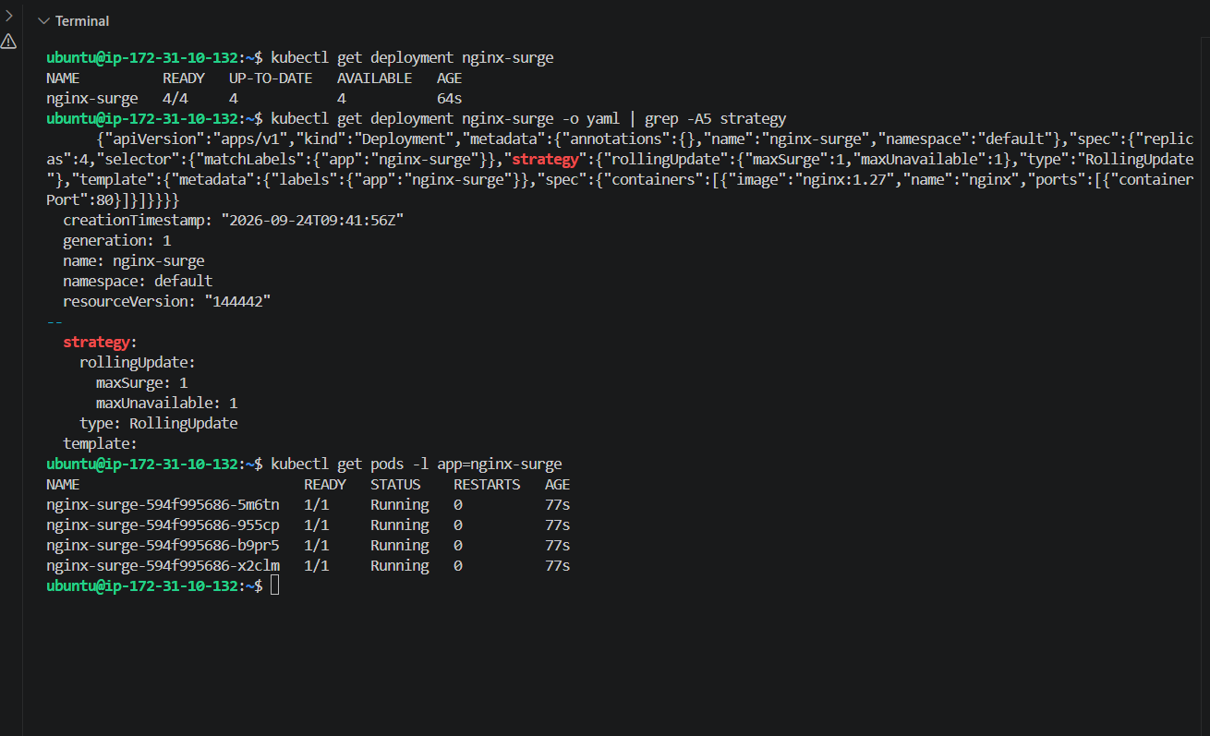
4. Trigger the rolling update
Change Nginx from 1.27 to 1.28:
kubectl set image deployment/nginx-surge nginx=nginx:1.28
Immediately watch the Pods:
kubectl get pods -l app=nginx-surge -w
After the update finishes:
kubectl rollout status deployment/nginx-surge
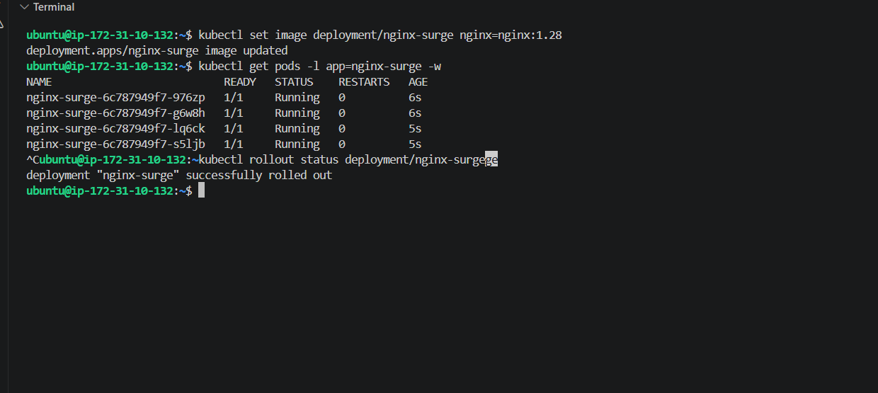
Task 6 — Custom Revision History Limit
Now we'll configure:
revisionHistoryLimit: 3
This tells Kubernetes to retain only 3 old ReplicaSets for rollback history.
1. Create the Deployment
nano deployment-history.yml
Paste the complete file:
apiVersion: apps/v1
kind: Deployment
metadata:
name: nginx-history
spec:
replicas: 3
revisionHistoryLimit: 3
strategy:
type: RollingUpdate
selector:
matchLabels:
app: nginx-history
template:
metadata:
labels:
app: nginx-history
spec:
containers:
- name: nginx
image: nginx:1.27
ports:
- containerPort: 80
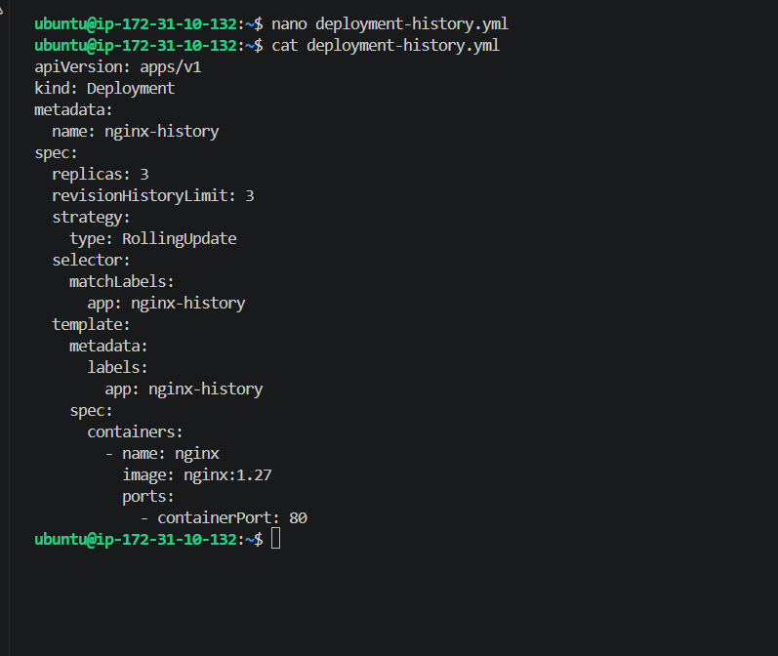
2. Apply
kubectl apply -f deployment-history.yml
Then:
kubectl rollout status deployment/nginx-history

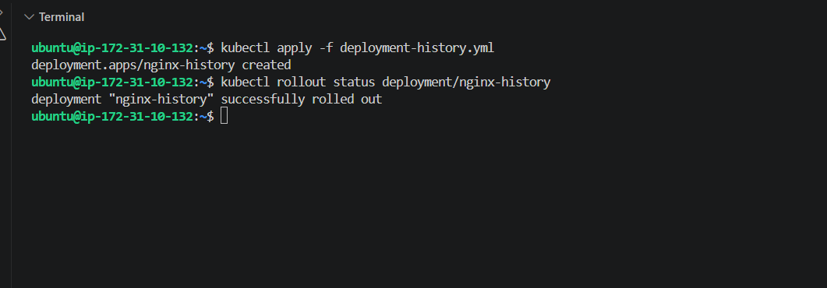
3. Verify the history limit
kubectl get deployment nginx-history -o yaml | grep -A3 revisionHistoryLimit
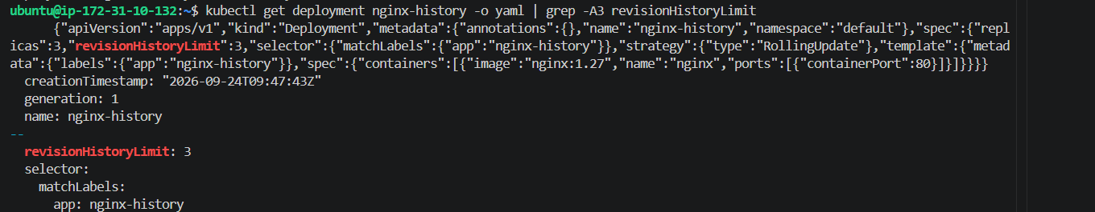
4. Check ReplicaSets
kubectl get rs -l app=nginx-history
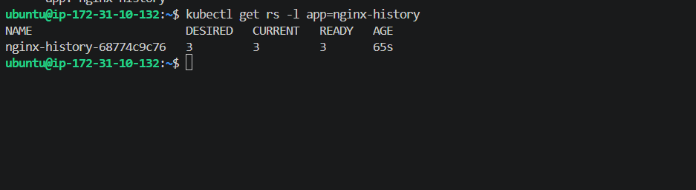
Task 7 — Pause Deployment During Update
Now we'll pause a Deployment, change the image, verify that rollout does NOT happen, then resume it.
1. Create the file
nano deployment-pause.yml
Paste this complete file:
apiVersion: apps/v1
kind: Deployment
metadata:
name: nginx-pause
spec:
replicas: 3
strategy:
type: RollingUpdate
selector:
matchLabels:
app: nginx-pause
template:
metadata:
labels:
app: nginx-pause
spec:
containers:
- name: nginx
image: nginx:1.27
ports:
- containerPort: 80
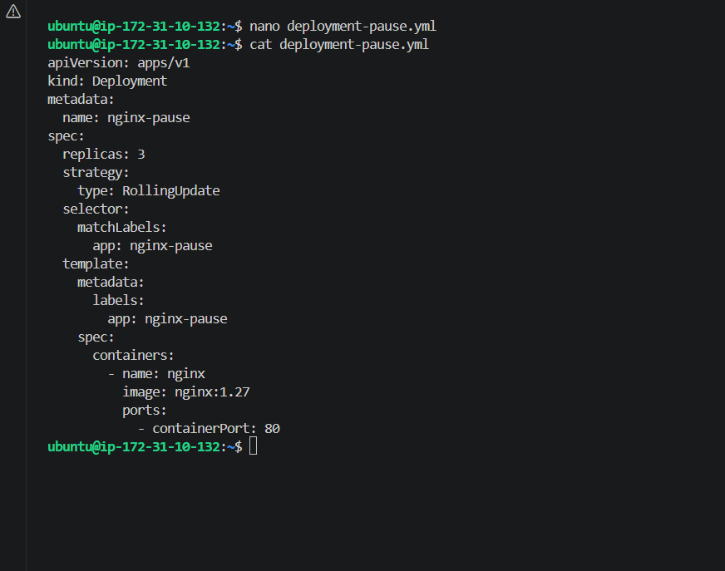
2. Apply it
kubectl apply -f deployment-pause.yml
kubectl rollout status deployment/nginx-pause
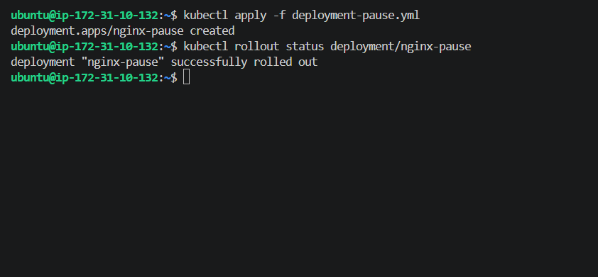
Then check:
kubectl get pods -l app=nginx-pause
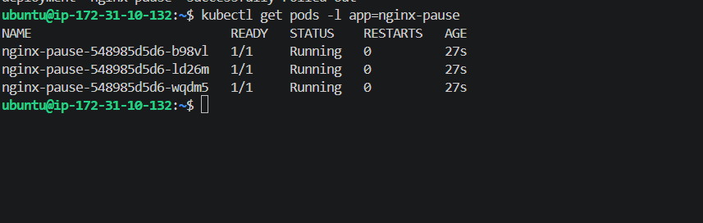
3. Pause the Deployment
kubectl rollout pause deployment/nginx-pause
Verify:
kubectl rollout status deployment/nginx-pause
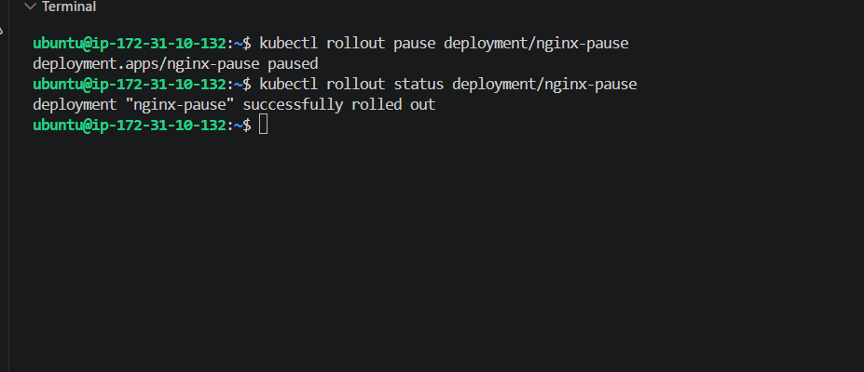
4. Update the image while paused
kubectl set image deployment/nginx-pause nginx=nginx:1.28
Now check:
kubectl get deployment nginx-pause -o wide
kubectl get pods -l app=nginx-pause
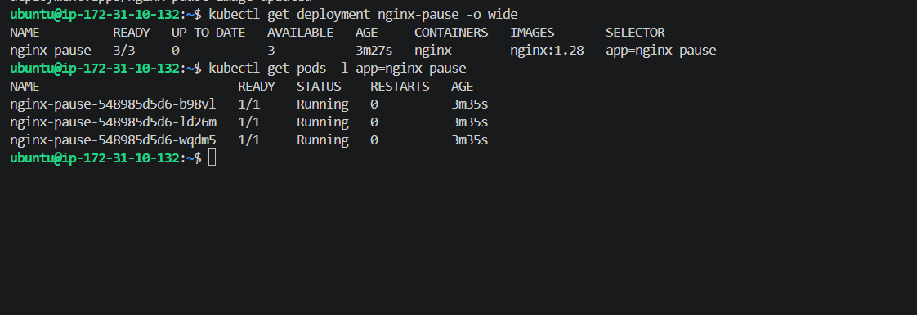
The Deployment is paused, so the new rollout should not proceed yet.
5. Resume the Deployment
kubectl rollout resume deployment/nginx-pause
Then:
kubectl rollout status deployment/nginx-pause
Finally:
kubectl get pods -l app=nginx-pause -o wide
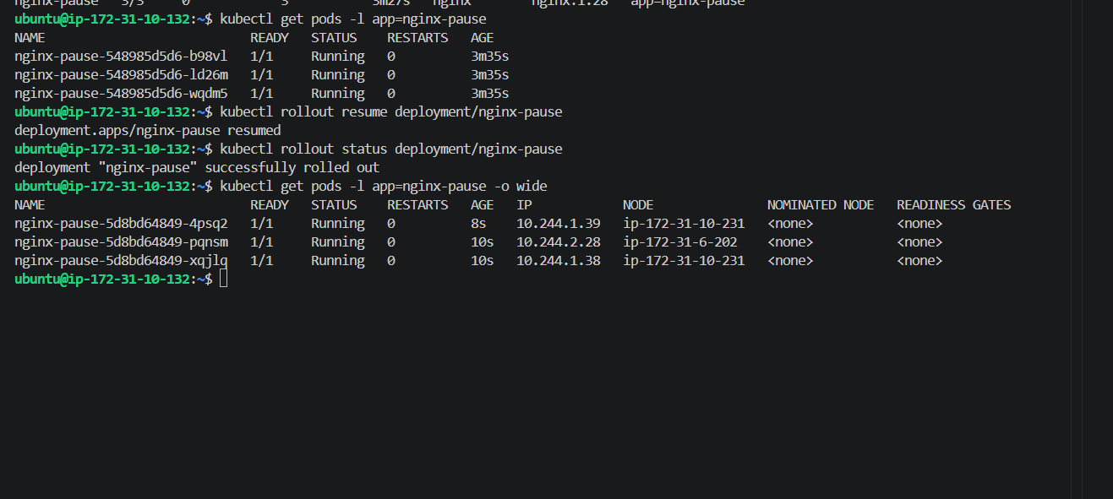
Task 8 — Resource Requests & Scheduler
This task demonstrates how Kubernetes uses CPU/Memory requests to decide which worker node should run a Pod.
1. Create the YAML
nano scheduler-resource.yml
Paste the complete file:
apiVersion: v1
kind: Pod
metadata:
name: scheduler-resource
labels:
app: scheduler-resource
spec:
containers:
- name: nginx
image: nginx:1.27
resources:
requests:
cpu: "500m"
memory: "256Mi"
limits:
cpu: "1000m"
memory: "512Mi"
ports:
- containerPort: 80
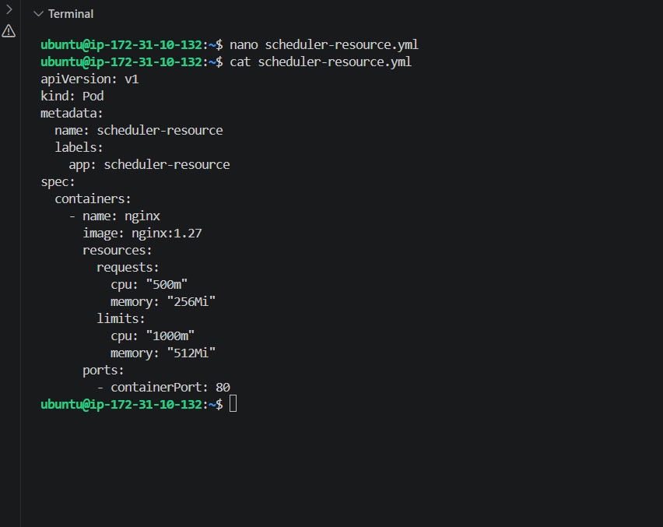
2. Create the Pod
kubectl apply -f scheduler-resource.yml
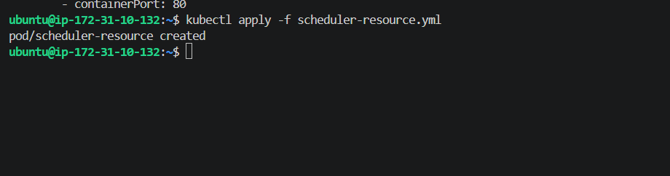
3. Check where Kubernetes scheduled it
kubectl get pod scheduler-resource -o wide
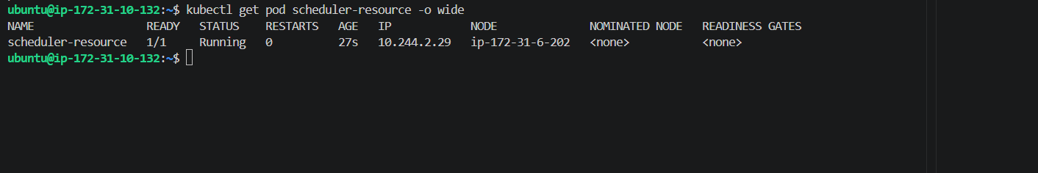
4. Check the resource requests
kubectl describe pod scheduler-resource
Look for:
Requests:
cpu: 500m
memory: 256Mi
Limits:
cpu: 1
memory: 512Mi
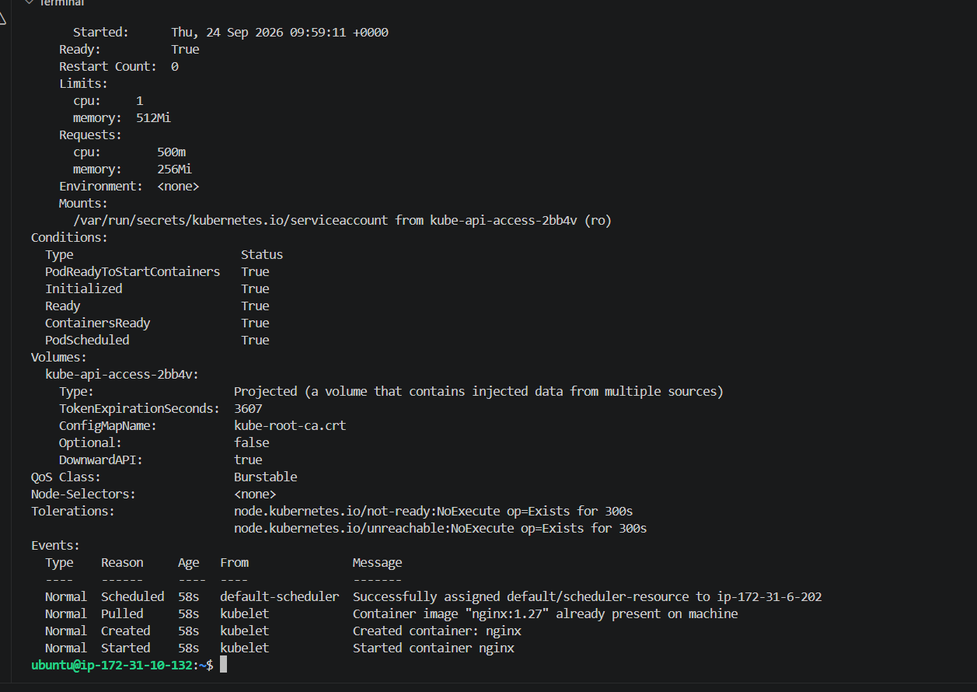
5. Check both worker nodes
kubectl get nodes -o wide
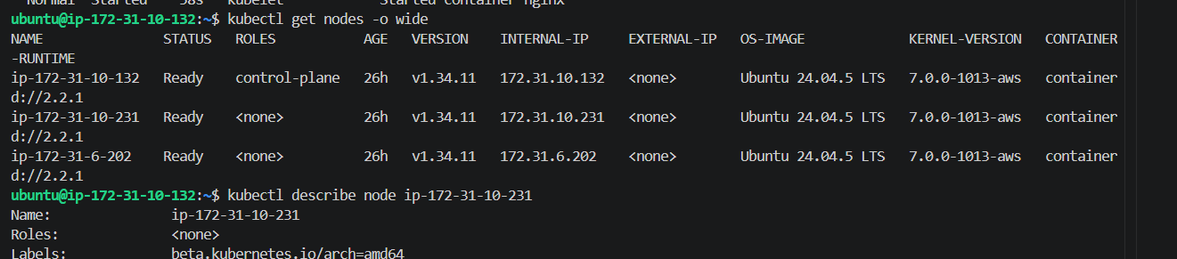
kubectl describe node ip-172-31-10-231
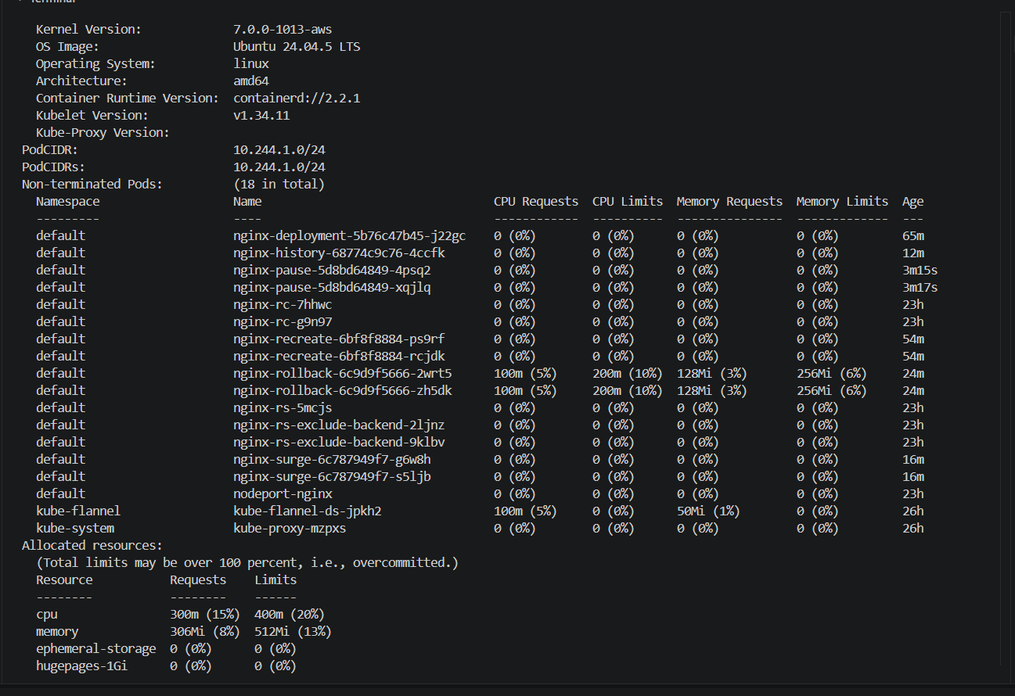
kubectl describe node ip-172-31-6-202
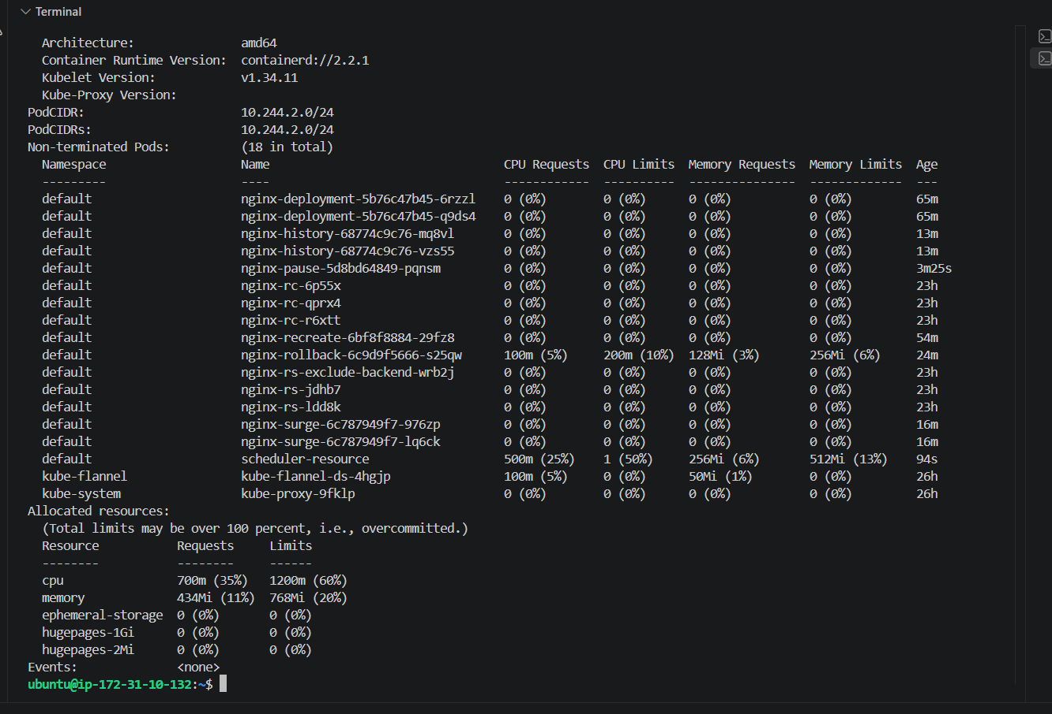
What we verified
Pod:
scheduler-resource
Status: Running
Node: ip-172-31-6-202
Resource request:
CPU: 500m
Memory: 256Mi
Resource limits:
CPU: 1
Memory: 512Mi
The scheduler successfully assigned the Pod to:
ip-172-31-6-202
And the node shows:
CPU Requests: 700m (35%)
Memory Requests: 434Mi (11%)
So Kubernetes considered the available resources before scheduling the Pod.

